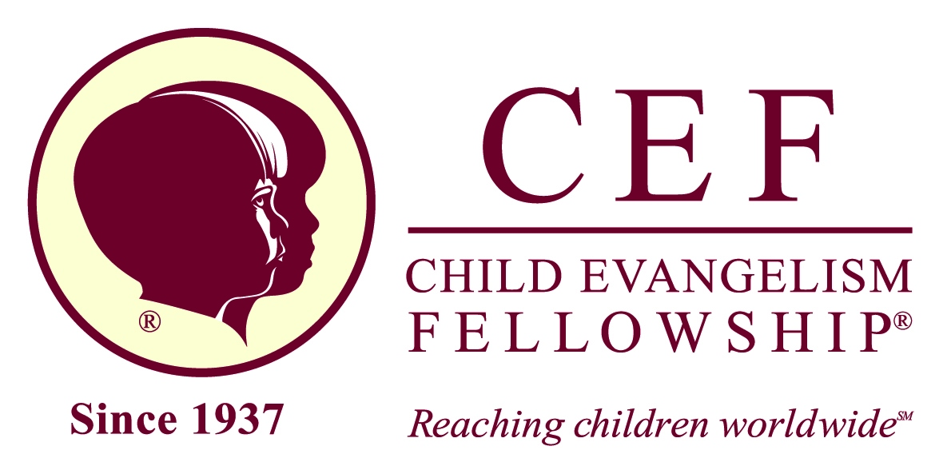

Dear Potential CEF Volunteer:
Thank you for volunteering to serve with us, taking the gospel to boys & girls! The ___________ Chapter is part of CEF of West Texas. In today’s society, child abuse and child accusations are occurring daily. Therefore, it is important that Child Evangelism Fellowship® take steps to protect the children to whom we minister and protect our volunteers from false accusations.
All background checks are done through our state office (CEF of WTX), using the services of Protect My Ministry. This is an online service that will also protect your personal information. To access the online form, go to: www.ministryopportunities.org/CEFWESTTEXAS (Please note that the form times-out after 40 minutes.) Thank you for completing the form as soon as possible.
The online form includes the following:
  - CEF’s Child Protection Policy (please read—important!)
  - CEF’s Statement of Faith and our Worker’s Compliance Agreement.
  - An opportunity to view CEF’s “Protecting Today’s Child” video online (12 mins.) or calling 1-866-878-4182 to listen to the presentation.
Here are some facts about the background check:
- The sources consulted for the screening are: National Combo Search (SSN Verification and Address History, National Criminal Database Search, Reverification of criminal records, Alias names.)
- Background checks are run again in 5 years.
- If you are inactive as a volunteer for one or more years and come back to serve with CEF, a background check must be rerun.
- We maintain a database on all volunteers and will keep your information confidential.
- Please Note: You cannot help in a Good News Club® until a b/g check is run for you. No exceptions.
As you begin volunteering with CEF, we want to get to know you. Please meet with your local CEF representative for a brief interview before helping with a club. At that time, present a government-issued ID (e.g., driver’s license). Thank you!
If you have any questions about our Child Protection Policy, please call the CEF of West Texas office manager, Pam Miller (940-687-7788), or me (940-781-0899). Thank you for helping to provide a safe environment for the children entrusted to our care.
Serving together,
Janet Johnson
Missionary State Director

CEF of West Texas, Inc.
P.O. Box 3811 Wichita Falls, Texas 76301
940-687-7788
Email: westtexascef@gmail.com  Website: www.cefwesttexas.com

